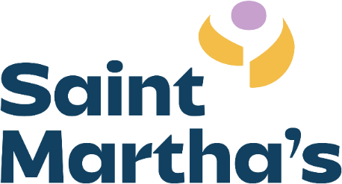

Job Announcement
Evening Women’s Shelter Advocate

Saint Martha’s, a safe place for women fleeing domestic violence and their children, is currently seeking a full-time women’s shelter advocate on our evening shift, working Tuesday-Saturday, 3pm-11:30pm. The salary range for this position is $35,000 -$45,000 annually, based on education and experience. Due to the residential nature of the shelter, this position is exclusively in-person.
The role of the Women’s Shelter Advocate is to support and empower women as they work to build a new life, free from violence. Using a trauma-informed lens, this position works directly with women in shelter to provide crisis intervention, community referrals, basic necessities, and help maintain a clean and safe environment for residents.
This position would include the following duties:
- Responding to immediate needs of shelter residents
- Completing intakes, assisting residents with goal progress, providing safety and support to residents healing from domestic violence
- Answering our crisis hotline and providing crisis intervention and referrals to callers and in person
- Assisting with cleaning, organizing, putting away donations, and other necessary tasks

Saint Martha’s offers equitable pay commensurate with the work required and competitive benefits including a 403(b) match; medical, dental, and vision insurance; Flexible Spending Account; training and professional development; Employee Assistance Plan; and paid sick, vacation, holiday, and wellness time. Recognizing the high rate of burn-out and secondary trauma in our field, Saint Martha’s works hard to recognize our employees and offer a considerate environment that values the quality of life of every person living and working here.
Successful candidates for this position will be flexible, empathetic, able to work with diverse populations, willing to work as part of a team, able to build rapport, understand healthy boundaries, and dedicated to the work of breaking the cycle of domestic violence. Knowledge of the dynamics of gender-based violence and intersectionality preferred.
Must be at least 21 years of age, have a car, and valid driver’s license and insurance. Must be able to navigate stairs in the event of an emergency or elevator outage.
Please email resume and cover letter to:
Cassie Esswein
Email: cassiee@saintmarthas.org
Phone: (314) 533-1313

Women are often less likely to apply for a job they don’t feel 100% qualified for. Saint Martha’s knows that qualifications come in many forms and invites anyone who is interested in this position but unsure to reach out for more information or go ahead and apply!

